Ethan Mills

CS-255

Southern New Hampshire University

October 17, 2024

Project 2

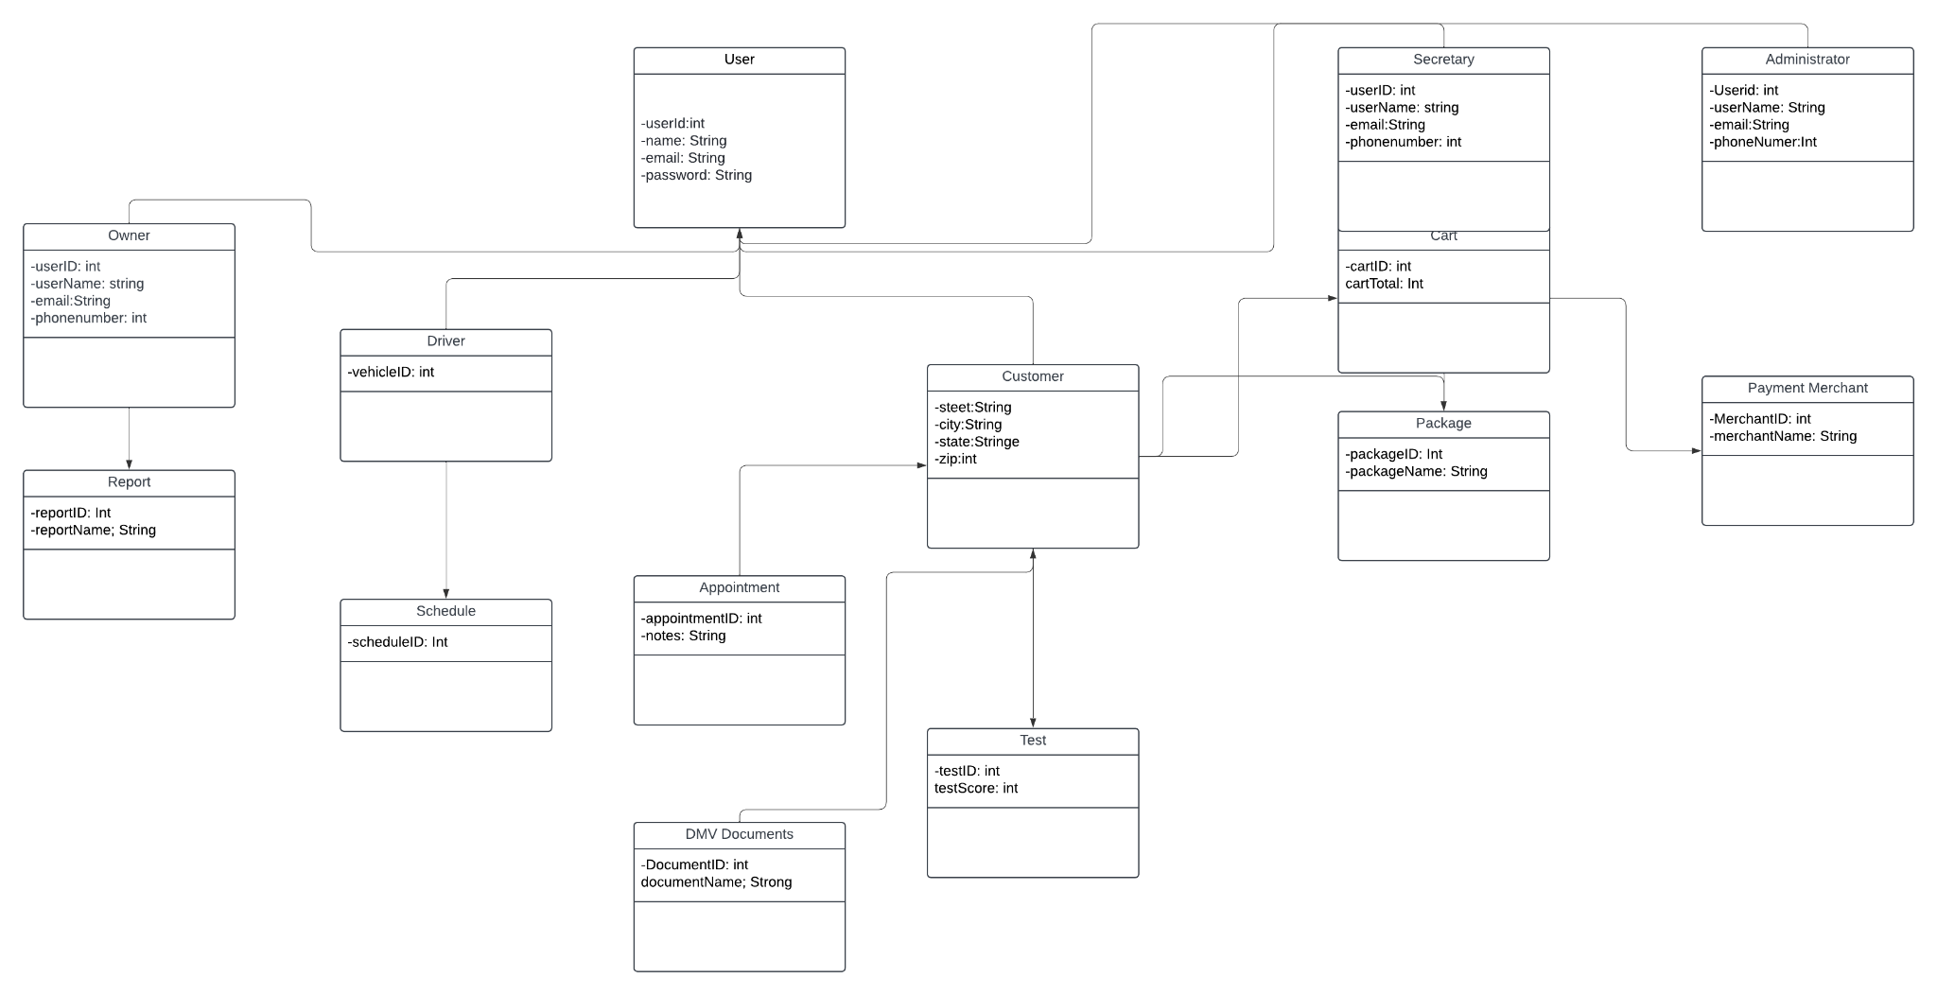

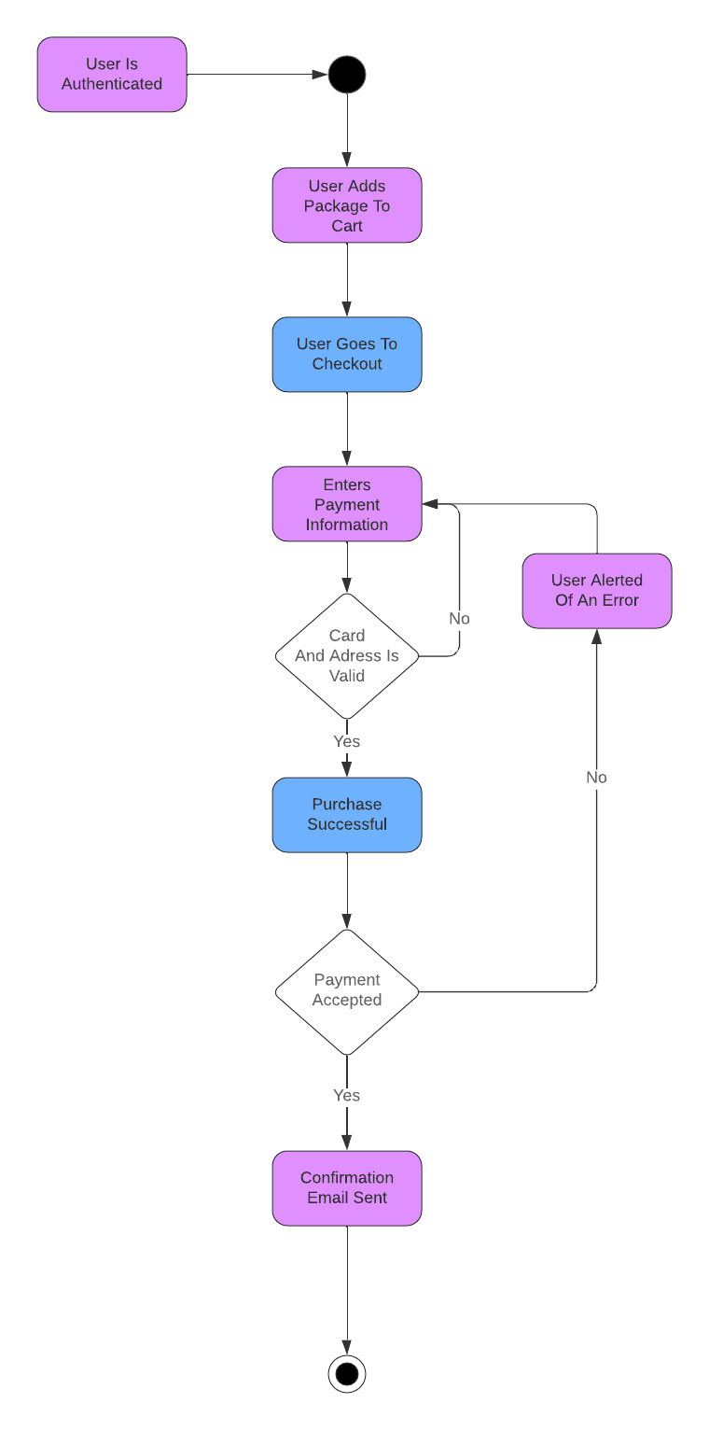

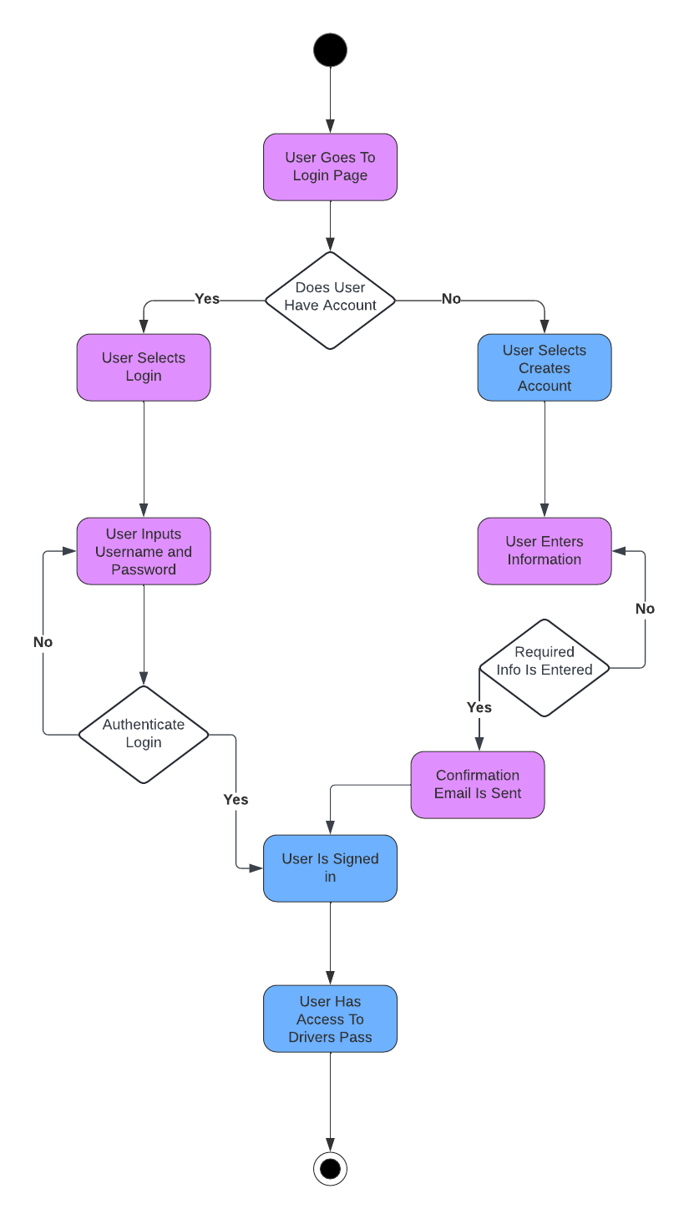

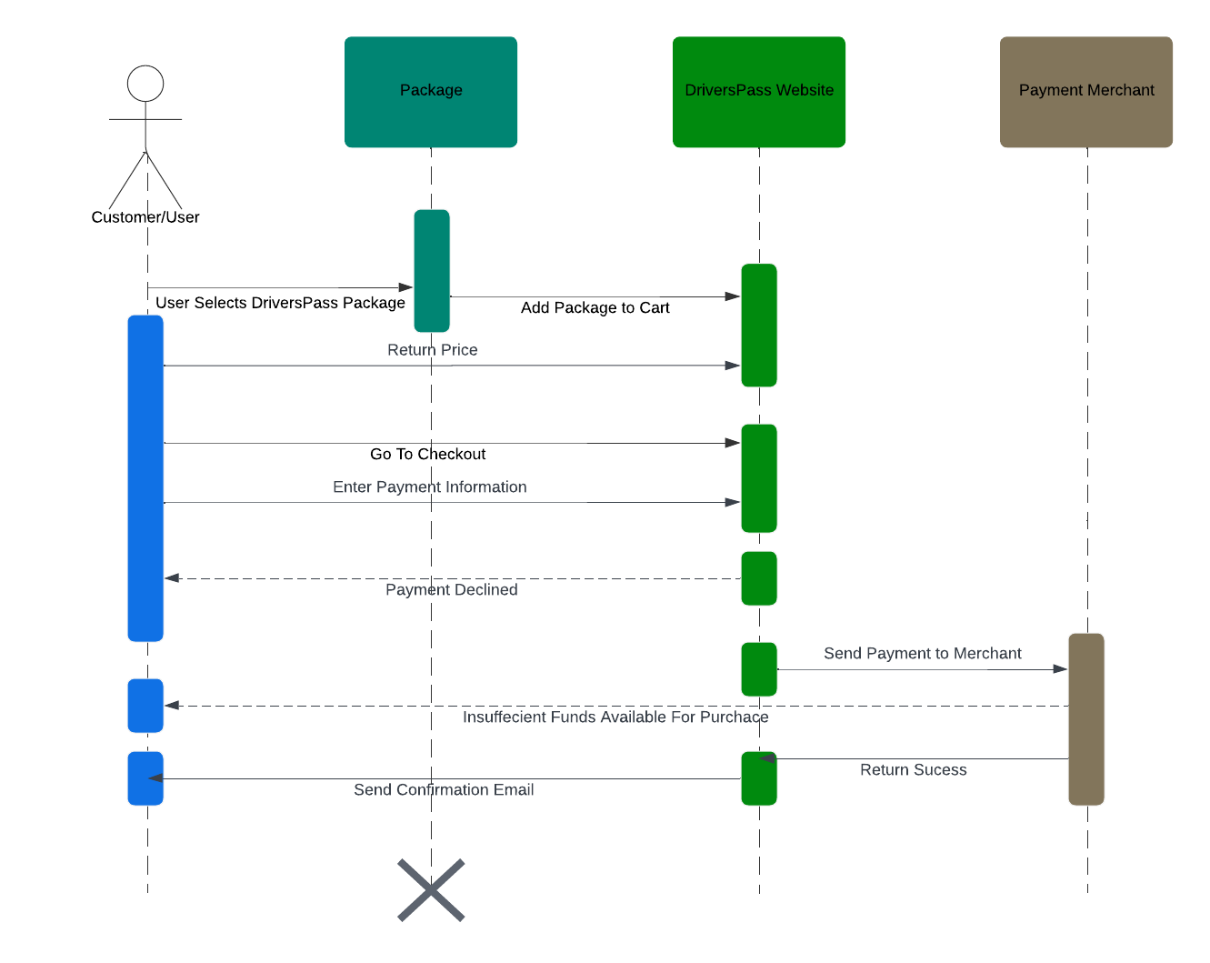

Technical Requirements

* Hardware
  + Internet connection access
  + Desktop or Mobile Device
  + Storage for database
  + Firewall for security
* Software
  + Security software
  + Latest SQL release
  + Backup for database and website incase of malfunctions or breaches
  + Utilize windows operating system
* Geographic
  + Databases server is in a secured location
  + Website to be accessed from inside the United States only